**Task 2.8**

**Word Cloud:**

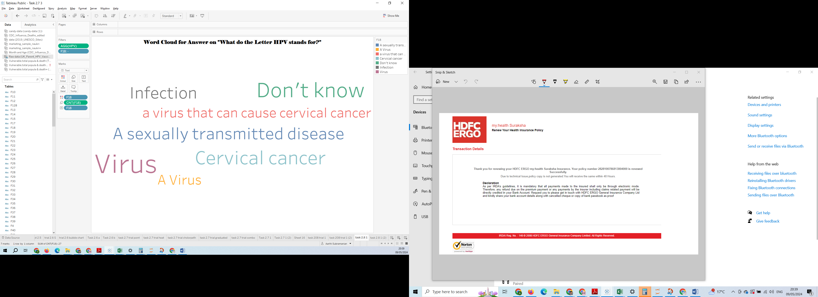

<https://public.tableau.com/app/profile/aarthi.subramanian/viz/Task2_81/task2_81?publish=yes>

**Bubble Chart**

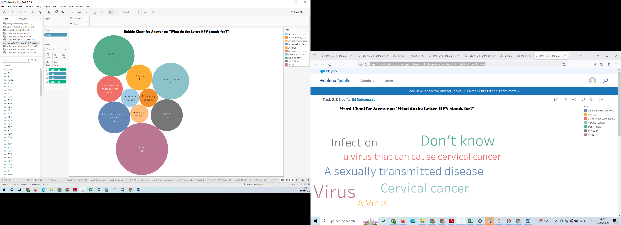

<https://public.tableau.com/app/profile/aarthi.subramanian/viz/Task2_82_17152808782560/task2_812?publish=yes>

**What the bubble chart tells you that the word cloud can’t?**

Bubble chart versions is more-precise about comparisons. It is easier to compare the sizes of bubbles than it is to compare the font sizes of different words. The Large circle notifies more count.

**Bonus Task:**

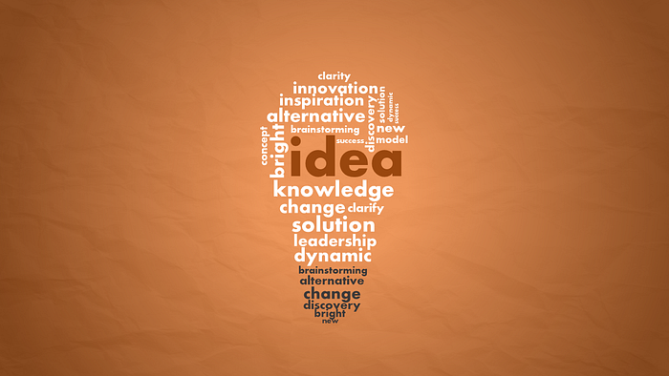

This is creative cloud illustrations for business, marketing, project management unstructured data. Here IDEA is in big font with different color, this is one which is more repeated word in data. This is designed inside bulb to convey message better. After Idea word the next top repeated word is Knowledge. This bonus task create more curiosity about this textual analysis.